t SEMESTER TWO
Papers written by Australian Maths Software

YEAR 12
MATHEMATICS SPECIALIST
UNIT 3-4, REVISION THREE
2016
Section Two
(Calculator–assumed)

Name: _________________________________

Teacher: ________________________________

TIME ALLOWED FOR THIS SECTION

Reading time before commencing work: 10 minutes
Working time for section: 100 minutes

MATERIAL REQUIRED / RECOMMENDED FOR THIS SECTION

To be provided by the candidate
Standard items: pens, pencils, pencil sharpener, highlighter, eraser, ruler.
Special items: drawing instruments, templates, notes on up to two unfolded sheet of A4 paper, and up to three calculators approved for use in the WACE examinations.

IMPORTANT NOTE TO CANDIDATES
No other items may be taken into the examination room. It is your responsibility to ensure that you do not have any unauthorised notes or other items of a non–personal nature in the examination room. If you have any unauthorised material with you, hand it to the supervisor before reading any further.

To be provided by the supervisor
Question/answer booklet for Section Two.
Formula sheet retained from Section One.
Structure of this examination

 | Number of questions available | Number of questions to be answered | Working time (minutes) | Marks available | Percentage of exam
Section One  Calculator—free | 9 | 9 | 50 | 2 | 35
Section Two  Calculator—assumed | 11 | 11 | 100 | 98 | 65
Total marks |  |  |  | 150 | 100

Instructions to candidates

1. The rules for the conduct of this examination are detailed in the Information Handbook. Sitting this examination implies that you agree to abide by these rules.

2. Write your answer in the Question/Answer booklet.

3. You must be careful to confine your responses to the specific questions asked and to
follow any instructions that are specific to a particular question.

4. Spare pages are provided at the end of this booklet. If you need to use them, indicate in the original answer space where the answer is continued i.e. give the page number.

5. Show all your working clearly. Your working should be in sufficient detail to allow your answers to be checked readily and for marks to be awarded for reasoning. Incorrect answers given without supporting reasoning cannot be allocated any marks. For any question or part question worth more than two marks, valid working or justification is required to receive full marks. If you repeat an answer to any question, ensure that you cancel the answer you do not wish to have marked.

6. It is recommended that you do not use pencil, except in diagrams.

7. The Formula Sheet is not to be handed in with your Question/Answer booklet.

10. (5 marks)
(a) An insect is at (1, -2, 2) and takes off in a straight line with a velocity of 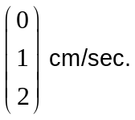
A chameleon has a long tongue that can dart out very quickly to catch insects
up to a distance of 70 cm.
The chameleon is sitting still at 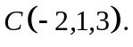

Is the insect in danger of getting caught for dinner? (4)

(b) Fully describe the set of points defined by 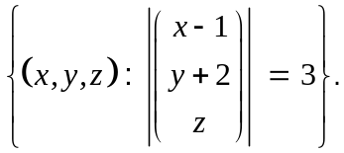 (1)
11. (8 marks)
Given 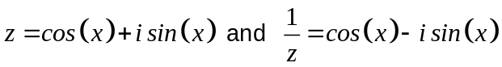
(a) find expressions for
(i) 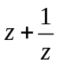 and 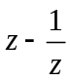 (1)

Hence find expressions for
(ii) 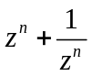 (3)

(iii) 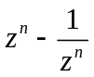 (1)

(b) Hence show that
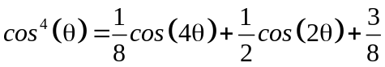 (3)

12. (12 marks)
(a) Consider the graph of the function below 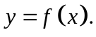

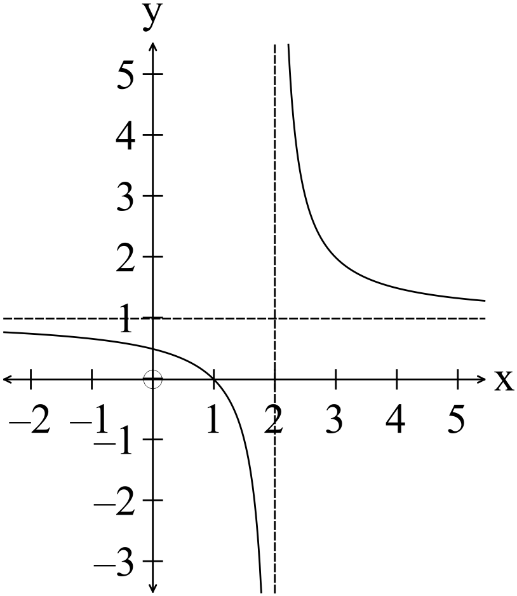

(i) Write down the equation of the function. (2)

(ii) Determine the equation of the inverse function and write down the domain
and range of the inverse function. (3)

(b) The functions 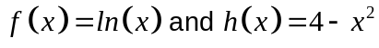 are given.
(i) Determine the domain and range of 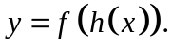 (3)

(ii) Determine the function 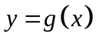 given 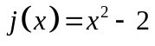 and
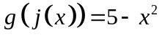. (2)

(iii) Determine whether the function 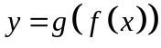 is a one to one function. (2)

13. (6 marks)
Given the functions 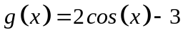 and 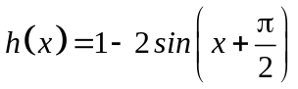 defined on the interval 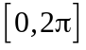.

(a) find the exact values where 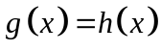. (3)

(b) hence determine the area enclosed between the two curves correct to three
decimal places. (3)

14. (7 marks)
Little Johnny had a bow and arrow. He fired an arrow into the air at an angle of 30º to
the horizontal, with a velocity of 30 metres a second. The back fence was 20 metres
away and 2 metres high.

If the arrow went over the fence he would have to go into his grumpy neighbour’s yard and he would be in trouble again. The neighbour does not like arrows coming over his fence!
. (a) Did the arrow go over the back fence? (6)
(b) How far away is the arrow expected to land? (1)
HINT: The acceleration due to gravity is -9.8 m s⁻².


15. (10 marks)

(a) A trophy is constructed by rotating the enclosed region, in the diagram below, about the axis.

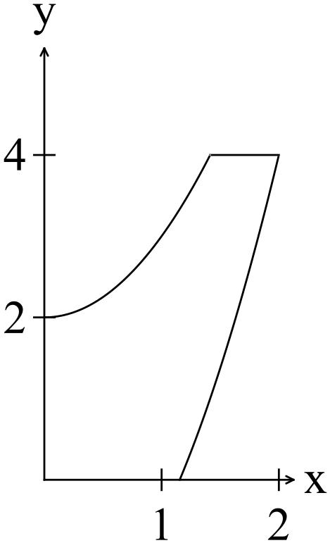
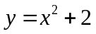
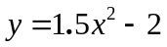
Write down the expression that if calculated gives the volume of the trophy. (4)

(b) A child’s plastic bracelet is made of 20 baubles linked together.
The bracelet is 20 cm long.
The design uses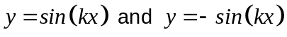.
(i) Each bauble has a diameter of 20 cm.
Determine the period and the value of . (2)

(ii) Calculate the number of cc of plastic are required to make one bracelet. (4)

16. (14 marks)
(a) The position of a particle is given by 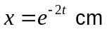where is measured in minutes.
Find the velocity and the acceleration at 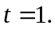 (3)

(b) A body moves according to the law 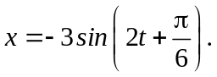
(i) Show the body is moving in SHM. (3)

(ii) Find the velocity and acceleration at 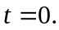 (2)

(iii) Find the displacement when 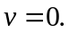 Explain your reasoning. (1)

(c) An oil spill is spreading in a circular fashion such that the radius is increasing at a
rate of 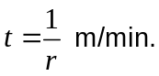
Show that the area is increasing at a constant rate. (2)

(d) Find in terms of given (1, 4) belongs to the function and 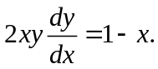
(3)

17. (8 marks)

Consider the triangle in the diagram below. Each of the points is on an axis.
The midpoints of

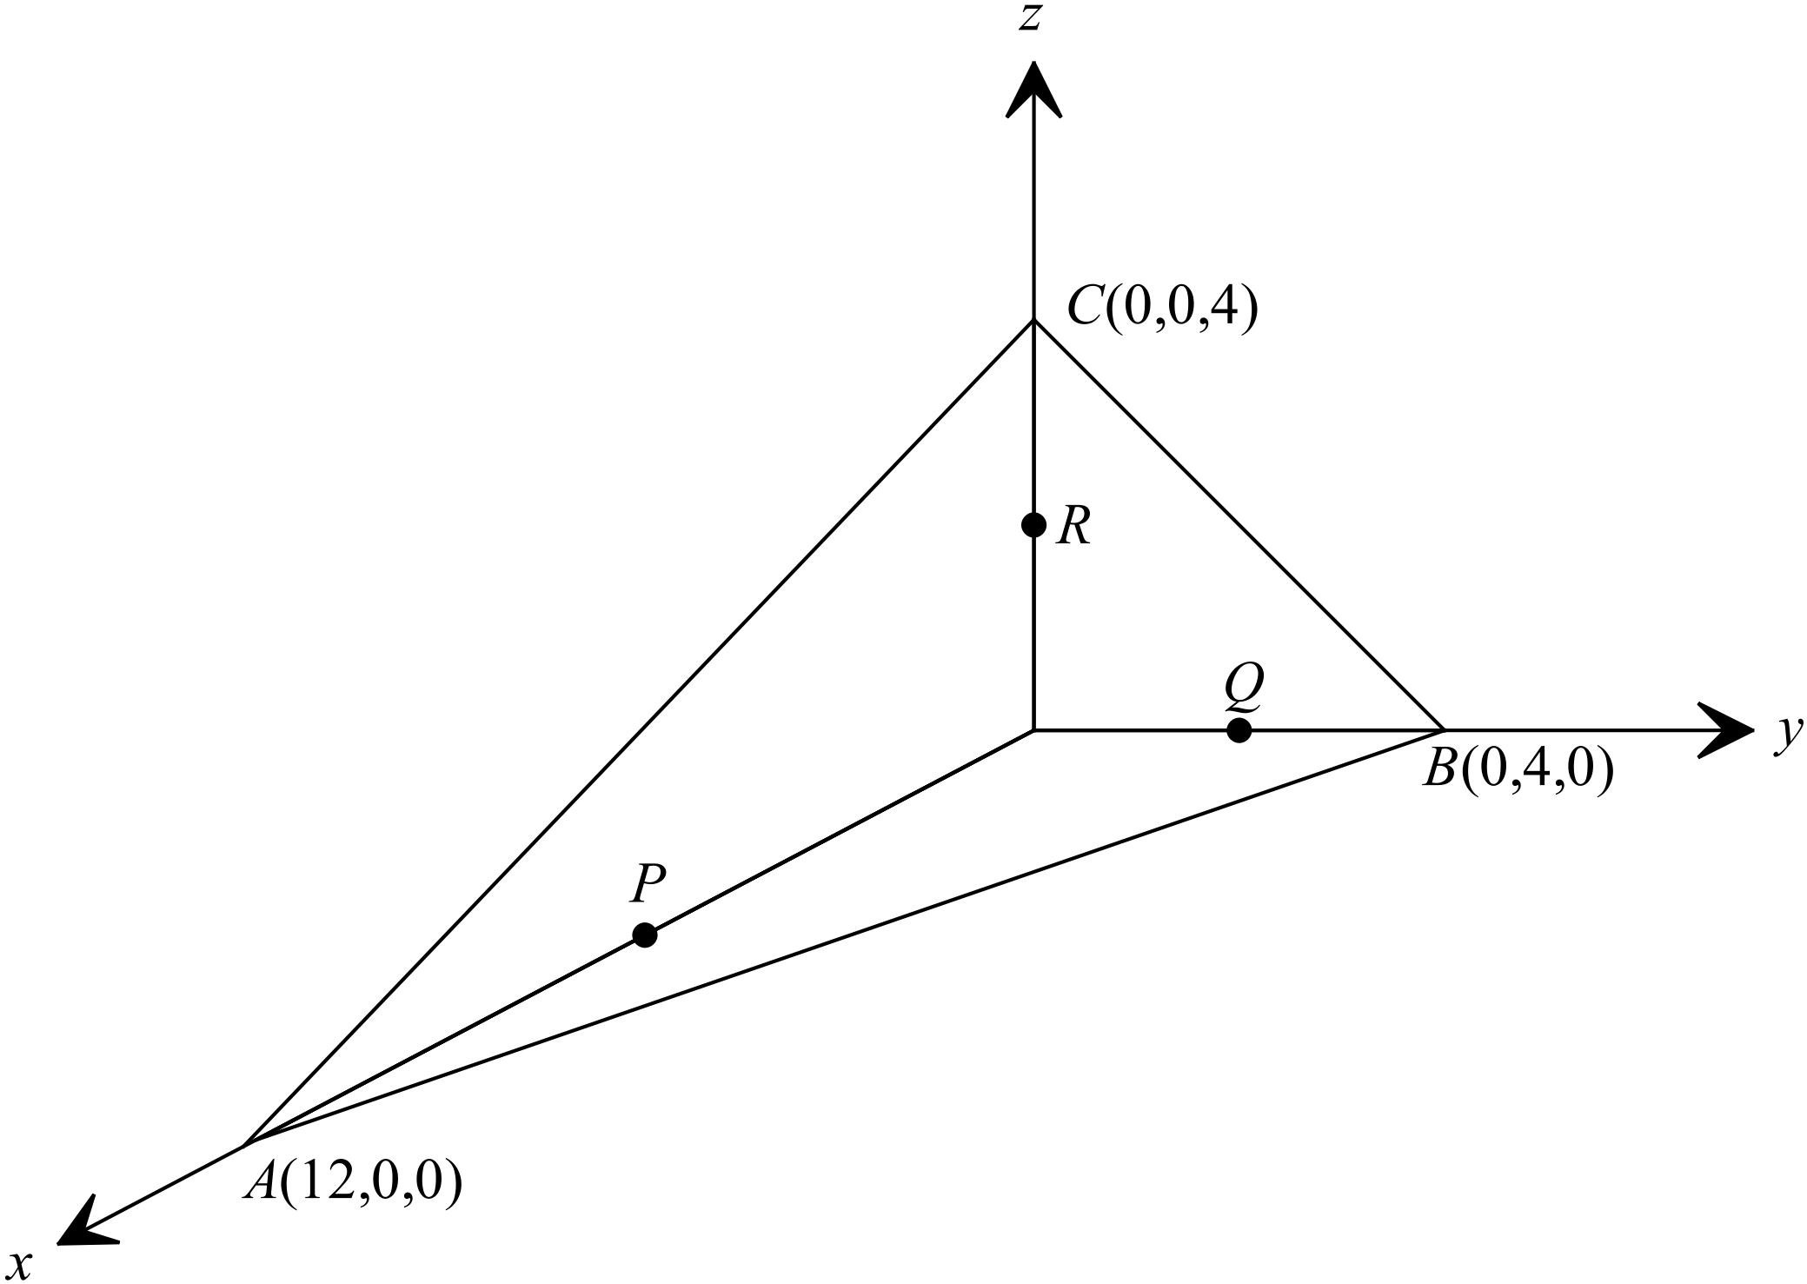

(a) Find the equation of the plane . (3)

(b) Show that the plane 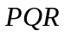is parallel to the plane. (1)

(c) Use the cross product of the vectors 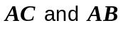to determine a vector normal
to the plane . (2)

(d) Use the cross product in (c) to find the area of the triangle. (2)

18. (8 marks)

(a) The mean weight of Granny Smith apples is 130 grams with a standard deviation
of 15 grams.

(i) What is the expected average weight and standard deviation of 6 randomly
selected Granny Smith apples? (3)

(ii) Explain why you expect the standard deviation of the 6 randomly selected
apples to be smaller than the standard deviation of the population. (2)

(b) The average time waiting on the phone when calling a certain institution is 20
minutes with a standard deviation of 6 minutes.
If three people rang the institution what is the average time they would wait and
what is the expected standard deviation? (3)

19. (7 marks)
A randomly selected group of 20 Year 12 girls have a mean height of 160 cm with a standard deviation of 10 cm.
(a) Use the data to predict the height and standard deviation of all WA Year 12 girls.
(3)

(b) State the 95% confidence limits for the mean height of Year 12 girls in WA. (2)

(c) Explain the difference between 95% confidence limits and 90% confidence limits.
(2)

20. (13 marks)

Carnac Island has a population of tiger snakes.

A snake showman dumped 40 tiger snakes on the island in 1930.
A study was made of the population of the snakes and it was found that the number can be estimated by the equation 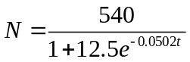 where is in years taken from 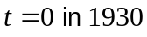.

(a) Estimate the number of tiger snakes on Carnac Island in
(i) 1964. (1)

(ii) 2015. (1)

(b) Determine the capacity of the island to support tiger snakes i.e. the maximum
number of snakes that can live on the island. Explain. (2)

(c) Find the rate of increase of snakes in 1990 and suggest whether the rate of
increase is increasing or decreasing at that time. (4)

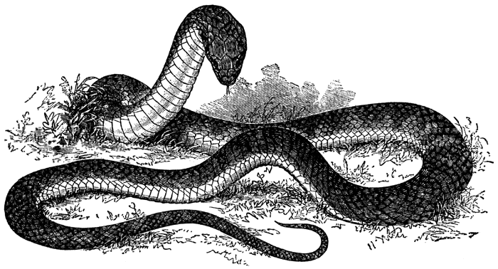
(d) Show how the logistic equation is derived from the formula 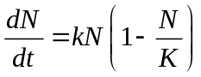
whererepresents the number (population) at time measured in years and
is the carrying capacity. (5)

END OF SECTION TWO

